Individual Report Summary

Rose Carey-Small (40403099)

As a team, we decided to create a game called RelicBound with inspiration from Marvel, Indiana Jones etc. to implement a multi-level design for all ages to be able to play. The aim of the game is to collect relics, weaponry and cryptograms to defeat the final boss by exploring eras and solving puzzles. At the beginning of the project, I helped build the storyboard and created the initial design of the puzzles therefore building on the users experience and elevating the complexity. These puzzles include cryptograms, sorts etc.

My key development contributions include final pages of the game including the *summary.html* page. Internal JavaScript and SQL has been added to this file to ensure that the link to the database and CSS applied to implement a consistent design through-out the game enhancing the user experience and providing a more elaborate ending. The summary.html page is a key component of the game and an advanced feature that showcases the complexity of the game.

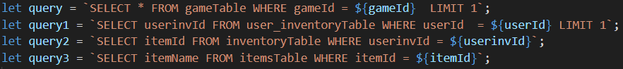

SQL queries in internal JavaScript that execute functions by clicking the load results button.

Internal CSS to create consistent design.

*summary.html*

Outputs a bullet point list of items in Inventory.

In *congratulations.html* I have implemented JavaScript to change the defeatedBoss value in the gameTable linked to the local stored gameID. This means that when the user arrives on the *summary.html* page, they will be able to access the updated value. This function is hidden from the user and adds to the complexity of the game.

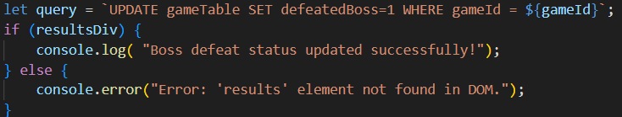

JavaScript prints in console

In the *trainStrat.html* and *bossFight.html* I have created a timer that will bring the user to the next html page linked and added sound effects to both bossFight.html and congratulations.html to differentiating from the game sound, notify the user of their victory and develop a more intricate game for the user to enjoy.

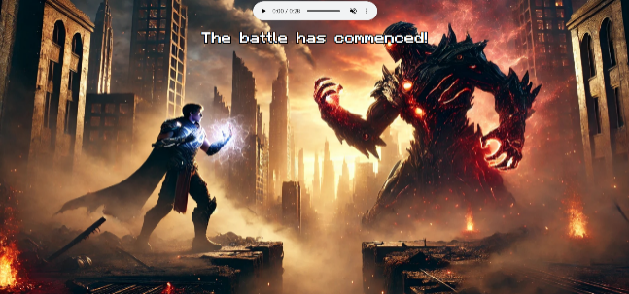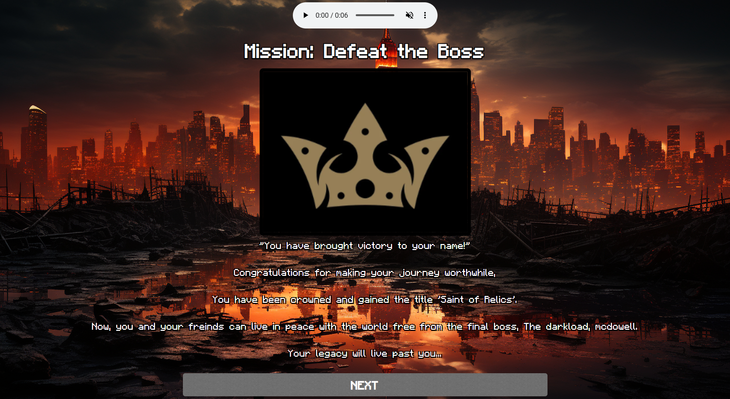

20secs

*congratulations.html*

*BossFight.html*

Internal functions to navigate to next window in 20 seconds.

This function is executed when the html is fully loaded.

With the integration of sound effects, I implemented a control bar allowing users to turn certain sound elements on/off including sound (mute/unmute) and play/pause. User experience and overall complexity are enhanced due to these inclusions.

*finalOption.html*

*finalTryDefeat.html*

External CSS file is linked to these files.



Other html pages I have contributed include finalOption.html and finalTryDefeat.html which utilise external CSS to implement a consistent design and provide the user to choose the route they want to approach the game leading to defeating the boss or ‘Game Over’ causing for good user interaction and a thrilling game. We added some user feedback throughout the script to further enhance gameplay with a smooth operation.

In terms of the database an SQL work, my focus throughout the game includes the creation of the SQL tables, relationships, data structure, and inserting sample data on phpMyAdmin. This would be a part of the advanced parts of the game including linking the database to the html using JavaScript, JSON, mySQL and FileZilla. This creating the frame for a functional game and allowed for queries to be run from the internal JavaScript and for commands to be run like inserting a new user instance or updating a piece of data using local storage and setting it to a new value.

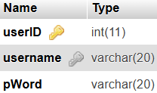

SQL to phpMyAdmin

I focused on the database design and completed the Entity Relationship Diagram as well as the Data Dictionary. This was important to understand what triggers were needed to create new instances throughout the tables and initialise the data.

Data Dictionary

ERD

Throughout this program I utilised AI to debug code after taking lecture notes into account for possible errors that I may have made. I also used console.log to debug my html codeI personally used Canva to generate images to keep the theme and design consistent. For sound effects I chose to use Pixabay as it had a wide range of sounds even with multiple search queries and I believe it add advanced features to the game and enhanced the user’s experience.